How to restore a Database using SQL Server Management Studio.
How to restore a database using SQL Server Management Studio Express.
First, navigate to Start -> Programs -> Microsoft SQL Server xxxx -> SQL Server Management Studio
Upon opening the program, you should be prompted with a Connect to Server box. Fill out the fields with your database information.
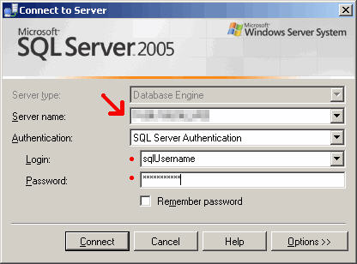
The Server Name field is the IP or server name of the Database Server.
The Authentication field should be SQL Server Authentication by default.
The Login is “sa”.
Contact IED Technical support for the password.
Upon connecting, you will see a window similar to the picture below. On the left, select/expand Databases and find the database called ‘Prizm’
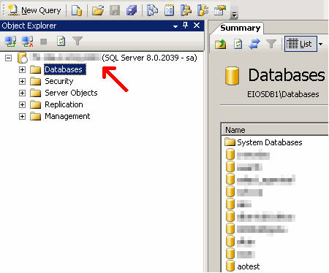
Right click on ‘Prizm’ and go to Tasks -> Restore -> Database
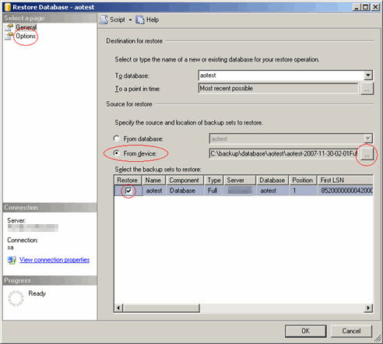
Select From device and click the small grey box on the right labeled ”...” . A window will pop up, Click Add and browse to “c:\iedsqldata\backup” (the location of your .bak file). Then select the file “Prizm.bak” and click OK.
Check the checkbox under the column Restore next to the database information in the bottom pane.
Go to the Options (top-left).
Check Overwrite the existing database.
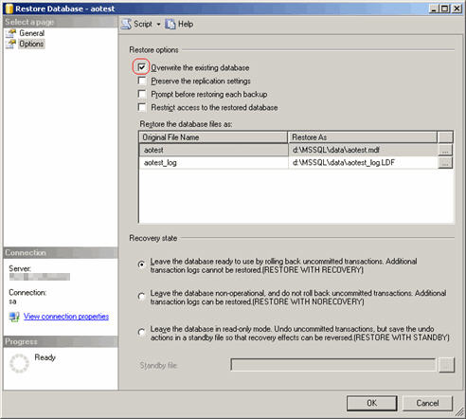
Click OK to begin the database restoration.
Now that your database is restored, we have to make sure the users associated with the database have proper permissions.
Collapse the Databases directory in the left window. Expand the Security folder and go to Logins and find the “ied” user associated with the database. Right click on the Username and go to Properties.
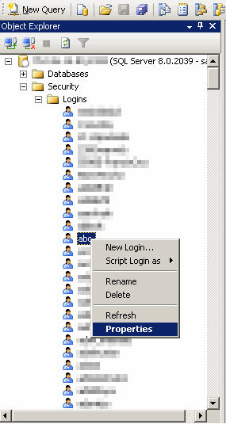
Go to the User Mapping on the top-left. Locate your “Prizm” in top-right window pane list and make sure the checkbox is checked next to it. Once “Prizm” is selected, make sure the db_owner checkbox is checked in the bottom window pane and click OK.
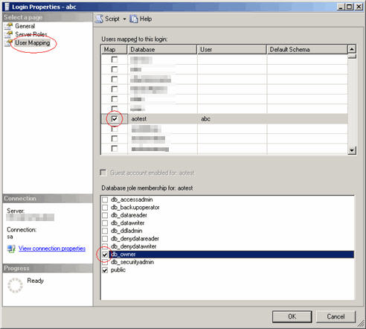
Repeat the above steps for the “prizm” user.

If this has completed with No Errors then you have successfully restored your database!

