Reconfiguring a Johnstown Motherboard After Battery Replacement

Ver 1.0 3 June 2020
After replacing the CR2032 CMOS battery, you will need to properly configure the BIOS in the motherboard. This is done as follows:
    - Connect the 12V power supply to the rear of the 1100/1200. A standby LED on the motherboard should illuminate.
    - Remove the ribbon header for the front panel indicators from the header on the motherboard (feature V in board drawing at below).
    - Momentarily touch a screwdriver to the two pins with RED background on this header. (This acts as a power-on switch.)
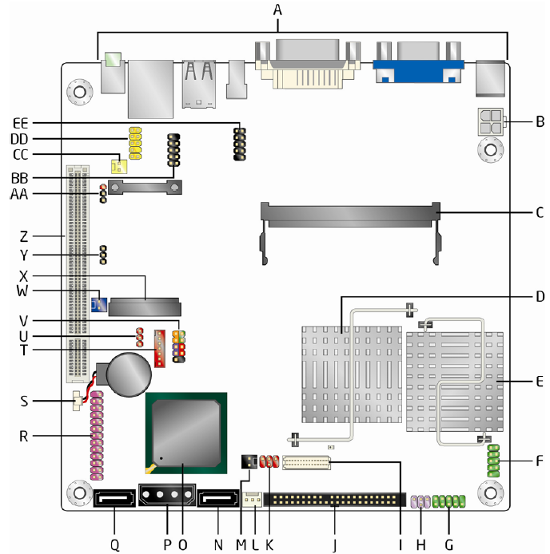
Note: If the unit fails to boot up, it may be necessary to reset the BIOS CMOS. See procedure at the end of this document for steps in accomplishing this.
    - Press function key F2 immediately upon seeing the Intel logo screen.
    - In the BIOS setup, press the right arrow () key once to select the Advanced menu.
    - Press the down arrow key to select the Drive Configuration option.
    - The first item in the menu, ATA/IDE Mode, should be selected. If not use the up/down arrow keys to select. The value should be [Native]. If not, press the (+) key on the keypad until the option “[Native]’ is displayed.
    - Press the down arrow key until the option Configure SATA is selected.
    - Press the plus (+) key on the keypad until the value is “[AHCI]”.
    - Press the Esc key.
    - Press the right arrow key two times to select the Power menu.
    - The first item in the menu, After Power Failure, should be selected by default. If not, use the up/down arrow keys to select.
    - If not already set, press the plus (+) key on the keypad until the option “[Power on]” is displayed.
    - Press the F10 key to save the settings.
    - Press the [Enter] key on the keyboard and select Yes in the Yes/No dialog that appears.

